**Review day 1 Lab**

Print out this duck using escape characters when appropriate.

[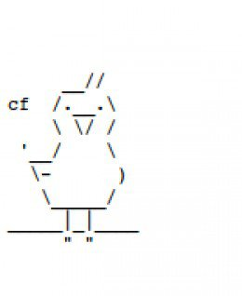](http://www.google.com/url?sa=i&rct=j&q=&esrc=s&source=images&cd=&cad=rja&uact=8&ved=0ahUKEwig-eLFlPfTAhWD7YMKHcaiDdwQjRwIBw&url=http%3A%2F%2Fwww.keywordsuggests.com%2FojW4e2gaQsxwKFSEQBj8XhTpMBh43dVT0Mj0nT7MhvTS2SatmsoTuZJ4XBfyCw89V*xaKtNOSARUIO2p7GZRXw%2F&psig=AFQjCNGAy4B8HF0BYAQ32FylTCZASgwxWg&ust=1495118329406062)

Bonus

Print out this lion

[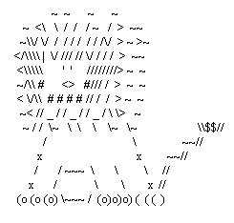](https://www.google.com/url?sa=i&rct=j&q=&esrc=s&source=images&cd=&cad=rja&uact=8&ved=0ahUKEwj1lenclPfTAhUI04MKHYvJC5wQjRwIBw&url=https%3A%2F%2Fwww.pinterest.com%2Fpin%2F78390849733401020%2F&psig=AFQjCNES1mgvJuSebbu6TqKvsVd55aAQlg&ust=1495118265783752)